Effects of Emotional Expression Intensity Mismatch on Speaker-Independent Speech Emotion Recognition
Project Report
Author: Chan Yunchen

Abstract
Speech emotion recognition (SER) systems may become unreliable when users express the same emotion at different intensities. This project investigated how mismatch between training and testing intensity affects speaker-independent emotion classification. Using RAVDESS recordings of Happy, Sad, and Angry speech, I extracted 31 pitch, energy, duration, and MFCC features and evaluated an RBF-SVM under matched, mismatched, and mixed-intensity conditions.
Matched-intensity experiments achieved Macro F1 scores of approximately 78–81%, while mismatched conditions decreased to approximately 39–46%. The errors were directional: Strong Happy speech was frequently classified as Angry, whereas Normal Angry speech was often classified as Happy or Sad after training on Strong expressions. Mixed-intensity training improved Macro F1 to approximately 73–74%, showing that varied training intensities can increase robustness.
Acoustic analysis indicated that intensity altered pitch, energy, and spectral characteristics. Separate evaluations on RAVDESS, EMO-DB, and CREMA-D also showed corpus-level and speaker-level performance differences. Overall, the results demonstrate that emotional intensity is an important source of training–testing mismatch and should be considered when developing SER systems for real-world human–computer interaction.
Keywords: speech emotion recognition, emotional intensity, acoustic features, MFCC, SVM

1. Introduction

1.1 Motivation
Modern voice interfaces can convert speech into text, but recognizing spoken words is different from recognizing how those words are expressed. When a user sounds frustrated, sad, or excited, a conventional speech-recognition system may still respond in the same way unless the user explicitly describes their emotion.
My interest in this problem began through interactions with AI systems. When an AI system gave me an incorrect answer, it could recognize the words I used to correct it, but it could not detect my frustration unless I explicitly stated that I was angry. This made me interested in whether a computer could use acoustic properties of speech to classify emotional expression.
I first built a small SER model that classified four emotions: Neutral, Happy, Sad, and Angry. During an informal test, only two of my four recordings were classified correctly, while all four recordings made by my mother were classified correctly. After listening to the recordings, I noticed that her Sad recording sounded more clearly sad and her Angry recording sounded more strongly angry. This observation suggested that emotional expression intensity might affect model performance.
This initial observation was not treated as scientific evidence. Instead, it motivated a controlled investigation of how Normal and Strong emotional expressions affect speech emotion recognition.

1.2 Research Problem
Many SER studies report a single overall accuracy or Macro F1 score. However, these scores may hide a distribution-mismatch problem. A model trained mainly on moderately expressed emotions may perform poorly when a user speaks with much stronger emotion. Similarly, a model trained on highly exaggerated speech may fail when emotions are expressed more subtly.
Emotional intensity is already included in important datasets such as RAVDESS, and previous research has established that intensity affects the recognizability and acoustic characteristics of emotional speech. Therefore, this project does not claim that emotional intensity has never been studied.
The narrower issue examined here is comparatively underexplored: how training–testing emotional-intensity mismatch affects a speaker-independent, classical machine-learning SER system, which emotions are affected most strongly, and which interpretable acoustic features change when intensity changes.

1.3 Research Questions
The main research question was:
How does emotional-intensity mismatch between training and testing affect speaker-independent speech emotion recognition on RAVDESS?
The project also examined the following questions:
- How much does performance decrease when the training and testing intensity levels do not match?
- Are the two mismatch directions—Normal-to-Strong and Strong-to-Normal—equally difficult?
- Which emotions are most frequently misclassified under each mismatch direction?
- Which feature groups—Pitch, Prosody, MFCC, or Fusion—are most affected by intensity mismatch?
- How do pitch, energy, duration, and MFCC characteristics change from Normal to Strong expression?
- Can mixed-intensity training improve the model’s robustness to both Normal and Strong speech?

1.4 Hypotheses
Before conducting the main experiment, I expected that:
- Matched-intensity conditions would produce higher Macro F1 scores than mismatched-intensity conditions.
- Combining pitch, energy, duration, and MFCC features would produce more robust performance than using only one feature group.
- Strong emotional expressions would show measurable changes in pitch and energy.
- Mixed-intensity training would reduce the performance loss caused by intensity mismatch.
The first, third, and fourth expectations were broadly supported. However, the Fusion feature set was not the most resistant to mismatch. Although it achieved the highest matched-condition performance, it also showed a substantial reduction when intensity was mismatched.

2. Technical Background

2.1 Speech Emotion Recognition
Speech emotion recognition is the task of predicting an emotional category from a speech signal. A basic SER pipeline contains four stages:
- collecting or importing digital speech recordings;
- extracting measurable acoustic features;
- training a classification model;
- evaluating predictions on previously unseen recordings.
The system in this project did not directly interpret a person’s internal emotional state. It classified acoustic patterns associated with emotion labels in the datasets.

2.2 Acoustic Features
The model used 31 acoustic features extracted with a Python-based audio-processing pipeline.

Pitch
Pitch describes how high or low a voice sounds and is related to the fundamental frequency of vocal-fold vibration. The project used:
- mean pitch;
- standard deviation of pitch.
Pitch standard deviation describes how much pitch varies during a recording.

Energy
Energy represents the strength or loudness of the speech signal. The project used:
- mean energy;
- standard deviation of energy.
Energy standard deviation describes how much loudness changes during the recording.

Duration
Duration is the total length of the audio recording. When speakers say the same sentence, a longer duration generally suggests slower delivery, although pauses and acting style may also influence the measurement.

MFCCs
MFCC stands for Mel-Frequency Cepstral Coefficients. MFCCs summarize the spectral shape of a speech signal using a frequency scale designed to approximate human auditory perception.
Rather than describing only how loud or high-pitched a sound is, MFCCs capture information about how energy is distributed across frequencies. This is related to voice quality, articulation, and the shape of the vocal tract.
The project extracted 13 MFCC coefficients. For each coefficient, both its mean and standard deviation were calculated:
- 13 MFCC means;
- 13 MFCC standard deviations.
Therefore, MFCCs contributed 26 of the 31 acoustic features.

2.3 Feature Vector
The complete Fusion feature vector contained:
- 1 duration feature;
- 2 energy features;
- 2 pitch features;
- 26 MFCC features.
This produced a total of 31 numerical features for every recording.

2.4 Feature Scaling and Missing Values
The features had very different numerical ranges. For example, pitch may be measured in hundreds of hertz, while energy may be represented by much smaller decimal values. Without scaling, features with larger numerical values could have an unfair influence on the SVM.
StandardScaler was therefore used to transform each feature using the mean and standard deviation calculated from the training data.
A small number of recordings had unsuccessful pitch extraction. These values were treated as missing and replaced using median imputation. Both imputation and scaling were fitted only on the training data in each evaluation fold to avoid data leakage.

2.5 SVM with an RBF Kernel
The main classifier was a Support Vector Machine with a Radial Basis Function kernel.
An SVM searches for a decision boundary that separates classes. A linear classifier such as standard Logistic Regression primarily forms linear decision boundaries. In contrast, the RBF kernel allows the SVM to form nonlinear boundaries.
This was appropriate because emotional categories are unlikely to be separated by a single straight boundary. A recording may have high pitch but low energy, or high energy with different spectral characteristics. The relationship among features is therefore likely to be nonlinear.

2.6 Evaluation Metrics

Accuracy
Accuracy is the number of correct predictions divided by the total number of predictions.

Recall
Recall measures how many recordings belonging to a particular emotion were correctly recognized:
Recall = Correct predictions for one emotion ÷ Total recordings of that emotion
For example, if 100 Angry recordings are tested and only 30 are correctly recognized as Angry, Angry recall is 30%.

Precision
Precision measures how many recordings predicted as a particular emotion actually belong to that emotion.

F1 Score
The F1 score combines precision and recall. A class receives a high F1 score only when both its precision and recall are reasonably high.

Macro F1
Macro F1 is calculated by finding the F1 score of every emotion separately and then averaging them with equal weight.
This differs from accuracy because a model could achieve high accuracy by performing well only on a large class. Macro F1 gives every emotion equal importance and shows whether the model can recognize all emotion categories rather than only the most common one.

Confusion Matrix
A confusion matrix shows the true emotion on one axis and the predicted emotion on the other. It reveals not only how many predictions are wrong, but also which emotions are confused with each other.

3. Methodology

3.1 Main Dataset
The main intensity experiment used the audio-speech section of RAVDESS. The complete four-emotion dataset used in the broader baseline contained:
Emotion | Number of Recordings
Neutral | 96
Happy | 192
Sad | 192
Angry | 192
Total | 672
RAVDESS contains recordings from 24 actors. Happy, Sad, and Angry include both Normal and Strong intensity labels. Neutral does not have a corresponding Strong-intensity category, so it was excluded from the main intensity-mismatch experiment.
The main experiment therefore used 576 Happy, Sad, and Angry recordings:
- 96 Normal and 96 Strong Happy recordings;
- 96 Normal and 96 Strong Sad recordings;
- 96 Normal and 96 Strong Angry recordings.

3.2 Feature Groups
Four feature groups were compared:
Feature Group | Features
A: Pitch | Pitch mean and pitch standard deviation
B: Prosody | Pitch, energy, and duration
C: MFCC | 13 MFCC means and 13 MFCC standard deviations
D: Fusion | Pitch, energy, duration, and MFCCs
This design allowed the contribution and robustness of each acoustic feature family to be compared.

3.3 Speaker-Independent Splitting
A speaker-independent evaluation was used. Recordings from the same actor were not divided between the training and testing sets.
The actors were divided using grouped cross-validation. In each fold, the model was trained on recordings from one group of actors and tested on recordings from actors that were not included in training.
This prevented the model from achieving a high score simply by remembering the voice, pitch range, or speaking habits of an actor it had already encountered.

3.4 Experimental Conditions
Six training–testing conditions were evaluated:
Condition | Training Data | Testing Data
Normal-to-Normal | Normal intensity | Normal intensity
Normal-to-Strong | Normal intensity | Strong intensity
Strong-to-Strong | Strong intensity | Strong intensity
Strong-to-Normal | Strong intensity | Normal intensity
Mixed-to-Normal | Normal and Strong intensity | Normal intensity
Mixed-to-Strong | Normal and Strong intensity | Strong intensity
Normal-to-Normal and Strong-to-Strong were the matched conditions.
Normal-to-Strong and Strong-to-Normal were the mismatched conditions.
Mixed-to-Normal and Mixed-to-Strong tested whether training on both intensities could improve generalization.

3.5 Machine-Learning Pipeline
For each fold, the following steps were conducted:
- select the appropriate training and testing intensity conditions;
- divide speakers into grouped training and testing sets;
- replace missing pitch values using the training-set median;
- standardize features using training-set statistics;
- train an RBF-SVM on the training recordings;
- predict emotions for the held-out speakers;
- calculate Accuracy, Macro F1, Recall, and the confusion matrix.
Placing imputation, scaling, and classification inside the same training pipeline prevented information from the testing data from influencing model preparation.

4. Intensity-Mismatch Results

4.1 Feature-Group Comparison
The average Macro F1 scores were:
Condition | A: Pitch | B: Prosody | C: MFCC | D: Fusion
Normal-to-Normal | 42.82% | 64.69% | 76.98% | 77.77%
Normal-to-Strong | 41.83% | 44.61% | 49.54% | 45.51%
Strong-to-Strong | 47.36% | 76.01% | 80.26% | 80.98%
Strong-to-Normal | 38.44% | 32.39% | 41.89% | 39.12%
Mixed-to-Normal | 43.45% | 48.28% | 73.02% | 72.60%
Mixed-to-Strong | 44.49% | 72.76% | 72.07% | 73.87%

Pitch alone produced relatively low performance in every condition. This indicates that pitch contains useful emotional information but is not sufficient by itself to distinguish Happy, Sad, and Angry reliably.
MFCC and Fusion features produced the highest matched-condition performance. The Fusion model reached 77.77% Macro F1 for Normal-to-Normal and 80.98% for Strong-to-Strong.
However, Fusion was also strongly affected by intensity mismatch. Its Macro F1 decreased to 45.51% for Normal-to-Strong and 39.12% for Strong-to-Normal.

4.2 Magnitude of the Mismatch Effect
For the Fusion model:
- Normal-to-Normal: 77.77%;
- Normal-to-Strong: 45.51%;
- Strong-to-Strong: 80.98%;
- Strong-to-Normal: 39.12%.
Normal-to-Strong mismatch caused a decrease of 32.26 percentage points compared with Normal-to-Normal.
Strong-to-Normal mismatch caused a decrease of 41.86 percentage points compared with Strong-to-Strong.
Therefore, mismatch in both directions substantially reduced performance, but the Strong-to-Normal direction caused a larger decrease.
The result also rejected the initial expectation that feature fusion would necessarily be the most robust feature set. Fusion achieved the best matched performance, but its mismatch drop was larger than the drop for MFCC-only features.

4.3 Emotion-Specific Recall
The Fusion model produced the following Recall scores:
Condition | Angry | Happy | Sad
Normal-to-Normal | 82.29% | 67.71% | 83.33%
Normal-to-Strong | 94.79% | 23.96% | 33.33%
Strong-to-Strong | 86.46% | 81.25% | 75.00%
Strong-to-Normal | 10.42% | 35.42% | 97.92%
Mixed-to-Normal | 60.42% | 65.62% | 93.75%
Mixed-to-Strong | 93.75% | 60.42% | 68.75%
The mismatch did not affect all emotions in the same way.
When the model was trained on Normal speech and tested on Strong speech:
- Happy recall decreased to 23.96%;
- Sad recall decreased to 33.33%;
- Angry recall remained high at 94.79%.
When the model was trained on Strong speech and tested on Normal speech:
- Angry recall decreased to only 10.42%;
- Happy recall was 35.42%;
- Sad recall remained high at 97.92%.
These results show that the two mismatch directions produced different types of failure.

4.4 Directional Confusion Patterns
In the Normal-to-Strong condition:
True Emotion | Predicted Happy | Predicted Sad | Predicted Angry
Happy | 23.96% | 0.00% | 76.04%
Sad | 32.29% | 33.33% | 34.38%
Angry | 5.21% | 0.00% | 94.79%
Approximately 76% of Strong Happy recordings were misclassified as Angry.
In the Strong-to-Normal condition:
True Emotion | Predicted Happy | Predicted Sad | Predicted Angry
Happy | 35.42% | 64.58% | 0.00%
Sad | 2.08% | 97.92% | 0.00%
Angry | 52.08% | 37.50% | 10.42%
More than half of Normal Angry recordings were misclassified as Happy, while 37.50% were misclassified as Sad.

A possible interpretation is that a model trained only on Normal speech may associate high pitch and high energy primarily with Angry speech. When it encounters strongly expressed Happy speech, the increased pitch and energy may move the recording toward the Angry region of the model’s feature space.
In the reverse direction, a model trained on Strong speech may learn that Angry speech normally contains very high pitch and energy. More moderately expressed Angry recordings may then fail to satisfy that learned pattern and be assigned to Happy or Sad.
This is an interpretation based on the acoustic results. It does not prove that pitch or energy alone directly caused every individual prediction.

4.5 Mixed-Intensity Training
Mixed-intensity training produced:
- 72.60% Macro F1 when testing on Normal speech;
- 73.87% Macro F1 when testing on Strong speech.
These values were slightly below the best matched-condition results but substantially higher than the mismatched conditions.
This suggests that including both Normal and Strong expressions in training helps the model learn a wider range of acoustic patterns. Mixed training therefore improves robustness when the intensity of future users is unknown.

5. Acoustic Feature Analysis

5.1 Purpose
The classification results showed that intensity mismatch reduced performance, but performance scores alone did not explain why. Acoustic analysis was therefore conducted to measure how speech features changed between Normal and Strong expressions.
Actor-level Normal and Strong feature averages were compared for Happy, Sad, and Angry. Percentage change and paired effect size, reported as Cohen’s dz, were calculated. False Discovery Rate correction was applied to reduce the probability of false-positive findings across multiple statistical comparisons.

5.2 Duration, Energy, and Pitch Changes
Emotion | Feature | Normal Mean | Strong Mean | Change
Happy | Duration | 1.6690 s | 1.9202 s | +15.05%
Happy | Energy Mean | 0.0115 | 0.0350 | +204.97%
Happy | Pitch Mean | 199.30 Hz | 273.59 Hz | +37.28%
Sad | Duration | 1.8315 s | 2.1373 s | +16.70%
Sad | Energy Mean | 0.0053 | 0.0123 | +133.78%
Sad | Pitch Mean | 169.78 Hz | 236.21 Hz | +39.12%
Angry | Duration | 1.8896 s | 2.0323 s | +7.55%
Angry | Energy Mean | 0.0180 | 0.0772 | +328.92%
Angry | Pitch Mean | 202.82 Hz | 301.91 Hz | +48.86%
Strong expression increased mean energy and mean pitch for all three emotions. Angry showed the largest change, with mean energy increasing by approximately 329% and mean pitch increasing by approximately 49%.
Energy and pitch variability also increased. For example:
- Happy energy standard deviation increased by approximately 244%;
- Sad pitch standard deviation increased by approximately 68%;
- Angry energy standard deviation increased by approximately 365%.
All 15 comparisons of duration, energy, and pitch remained statistically significant after FDR correction.
These findings show that Strong speech was not simply a louder version of Normal speech. It also differed in pitch, pitch variability, duration, and spectral characteristics.

5.3 MFCC Changes
The project examined 26 MFCC summary features: the mean and standard deviation of 13 coefficients.
Emotion | Mean Absolute Effect Size | Significant MFCC Features | Total MFCC Features | Strongest Feature
Happy | 0.7673 | 15 | 26 | MFCC 1 Mean
Sad | 0.6180 | 17 | 26 | MFCC 1 Mean
Angry | 0.6983 | 13 | 26 | MFCC 1 Mean
MFCC 1 Mean produced the largest effect for all three emotions. This indicates that intensity influenced the spectral representation of speech as well as pitch and energy.

The MFCC analysis helps explain why even the MFCC-only classifier was affected by intensity mismatch. Intensity changes the input distribution across several spectral features, so a model trained at only one intensity may encounter unfamiliar feature combinations during testing.

5.4 Interpretation
The acoustic analysis supports the interpretation that intensity mismatch is a feature-distribution problem.
For example, Strong Happy and Strong Angry speech both showed increased pitch and energy. A model trained only on Normal recordings may not have learned how to separate these emotions when both appear with much stronger acoustic values.
Similarly, a model trained only on Strong Angry speech may expect very high energy and pitch. When it receives Normal Angry speech, the recording may appear too weak to match the learned Angry region.
However, these analyses show association rather than direct causation. Additional model-level interpretation would be required to determine exactly how each feature influenced each prediction.

6. External Volunteer Pilot

6.1 Purpose and Recording Design
A small external pilot was conducted to determine whether the pipeline could be applied to home-recorded speakers who were not part of RAVDESS.
Three volunteers recorded:
- three Neutral recordings;
- three Weak and three Strong Happy recordings;
- three Weak and three Strong Sad recordings;
- three Weak and three Strong Angry recordings.
The expected total was 21 recordings per speaker. After file checking and duplicate detection, the final dataset contained:
- Speaker S01: 21 recordings;
- Speaker S02: 21 recordings;
- Speaker S03: 20 recordings.
The final pilot therefore contained 62 recordings. One Happy-Weak repetition from S03 was missing because two uploaded files contained the same recording.

6.2 Acoustic Validation
Across the nine speaker–emotion pairs, Strong recordings produced higher energy and pitch in every pair.
Feature | Weak Mean | Strong Mean | Mean Change
Energy Mean | 0.0320 | 0.1125 | +262.28%
Pitch Mean | 150.45 Hz | 232.79 Hz | +52.85%
Duration | 3.1564 s | 2.4028 s | −21.29%
Strong energy was higher in all nine speaker–emotion pairs. Strong pitch was also higher in all nine pairs. Strong recordings were generally shorter in this pilot, although this duration pattern differed from the RAVDESS actor-level result.
This difference demonstrates that acoustic expression patterns may vary across speakers, recording tasks, and datasets.

6.3 External Classification Results
Neutral recordings were excluded from the intensity comparison because they did not have separate Weak and Strong labels. The remaining recordings were tested with models trained on RAVDESS.
Training Condition | Test Intensity | Files | Accuracy | Macro F1
Normal Trained | Weak | 26 | 34.62% | 17.14%
Normal Trained | Strong | 27 | 33.33% | 16.67%
Strong Trained | Weak | 26 | 34.62% | 23.15%
Strong Trained | Strong | 27 | 44.44% | 36.93%
Mixed Trained | Weak | 26 | 53.85% | 48.33%
Mixed Trained | Strong | 27 | 48.15% | 44.97%
Mixed-intensity training produced the highest external Macro F1 for both Weak and Strong recordings. This pattern is consistent with the idea that exposure to varied intensity during training can improve robustness.
However, the pilot results were much lower and less consistent than the main RAVDESS results. Possible reasons include the very small number of volunteers, differences in microphones and recording environments, language or accent differences, and differences between professional acted speech and home-recorded emotional expression.
The pilot should therefore be interpreted as an exploratory demonstration rather than confirmatory evidence.

7. Three-Corpus Extension: Within-Corpus Speaker-Independent Evaluation

7.1 Purpose and Experimental Design
Following academic feedback, I extended the project to examine whether the same SER pipeline would produce consistent results across different speech corpora. This extension did not combine the corpora and was not a cross-corpus experiment. Instead, RAVDESS, EMO-DB, and CREMA-D were evaluated separately under the same experimental framework.
Only the four emotions shared by all three corpora—Neutral, Happy, Sad, and Angry—were retained. The datasets included:
- RAVDESS: 672 recordings from 24 speakers;
- EMO-DB: 339 recordings from 10 speakers;
- CREMA-D: 4,898 recordings from 91 speakers.
The same 31 acoustic features, preprocessing pipeline, and RBF-SVM classifier were used for each corpus. Leave-One-Speaker-Out evaluation was conducted separately within each corpus.
In every iteration, all recordings from one speaker were reserved for testing, while the recordings from all remaining speakers were used for training. This prevented the model from encountering the test speaker during training.
This extension did not repeat the intensity-mismatch experiment on all three corpora. Its purpose was to establish comparable within-corpus speaker-independent baselines and investigate corpus-level and speaker-level variability.

7.2 Data-Quality Check
Pitch extraction failed for a small number of recordings because no reliable fundamental frequency could be detected.
Corpus | Pitch Failures | Total Recordings | Failure Rate
RAVDESS | 2 | 672 | 0.30%
EMO-DB | 0 | 339 | 0.00%
CREMA-D | 489 | 4,898 | 9.98%
Failed pitch measurements were treated as missing values and replaced using median imputation fitted only on the training data.
The higher failure rate in CREMA-D suggests that feature-extraction reliability can itself vary across corpora, possibly because of differences in speakers, recording conditions, or vocal characteristics.

7.3 Overall Performance
Corpus | Accuracy | Overall Macro F1 | Mean Speaker Macro F1 | Speaker-Level SD
RAVDESS | 66.22% | 64.78% | 62.11% | 13.26
EMO-DB | 80.83% | 81.69% | 78.51% | 10.39
CREMA-D | 69.44% | 69.28% | 67.46% | 13.04
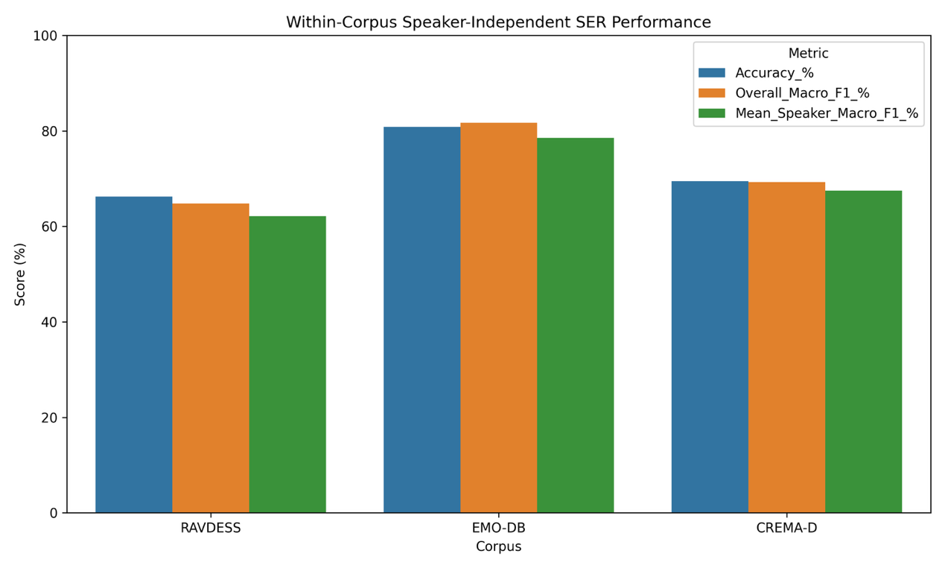[Figure 1: Within-corpus speaker-independent SER performance]

EMO-DB produced the highest overall performance, reaching a Macro F1 of 81.69%. CREMA-D achieved an intermediate Macro F1 of 69.28%, while RAVDESS obtained 64.78%.
Overall Macro F1 was calculated after combining all held-out predictions, so each recording contributed equally.
Mean Speaker Macro F1 was calculated separately for every held-out speaker and then averaged, so each speaker contributed equally regardless of the number of recordings.
The lower mean speaker scores indicate that strong overall performance did not necessarily imply equally reliable performance for every unseen speaker.
These differences should not be interpreted as evidence that one corpus is inherently better. The corpora differ in language, acting style, recording environment, number of speakers, sample size, and class distribution. Therefore, the results show corpus-dependent performance but do not establish which individual factor caused the differences.

7.4 Emotion-Specific Recall
Corpus | Neutral | Happy | Sad | Angry
RAVDESS | 59.38% | 63.54% | 61.46% | 77.08%
EMO-DB | 92.41% | 60.56% | 98.39% | 76.38%
CREMA-D | 71.73% | 57.44% | 71.65% | 77.26%
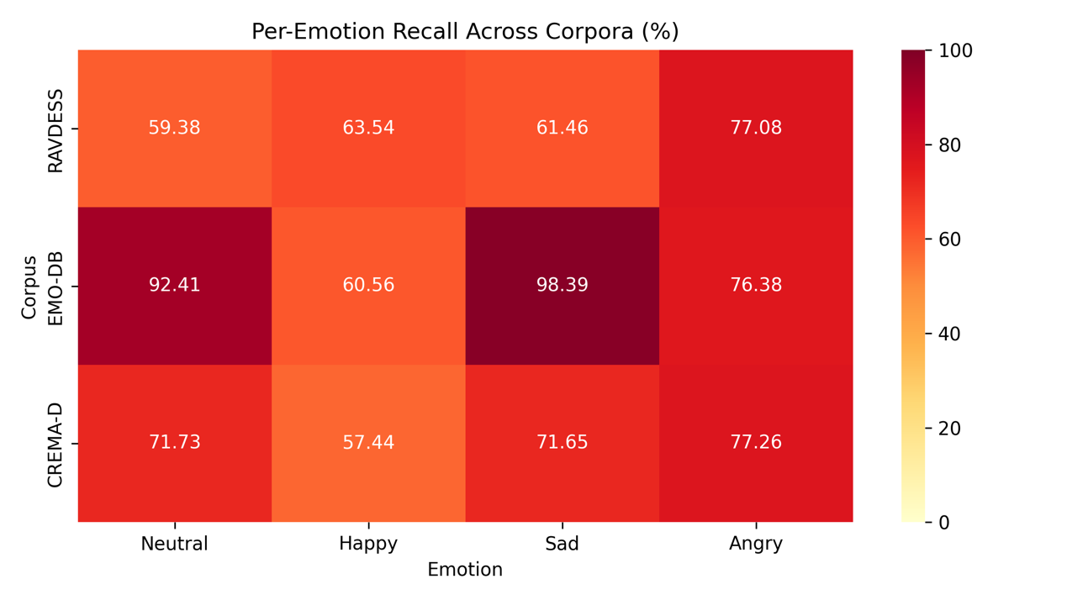[ Figure 2: Per-emotion Recall across the three corpora]
Angry recall was notably consistent across the three corpora, remaining between approximately 76% and 77%. In contrast, Happy was comparatively difficult to recognize, especially in EMO-DB and CREMA-D.
EMO-DB achieved particularly high recall for Neutral and Sad, which contributed to its higher overall Macro F1.
These findings suggest that corpus differences do not affect every emotion in the same way. Some emotional categories may have more consistent acoustic patterns across speakers and datasets, whereas others may depend more strongly on language, acting style, or individual expression.

7.5 Speaker-Level Variability
Corpus | Mean Macro F1 | SD | Minimum | Median | Maximum | Range
RAVDESS | 62.11% | 13.26 | 39.22% | 61.86% | 84.29% | 45.07
EMO-DB | 78.51% | 10.39 | 65.17% | 75.18% | 97.34% | 32.17
CREMA-D | 67.46% | 13.04 | 25.77% | 67.79% | 92.65% | 66.88
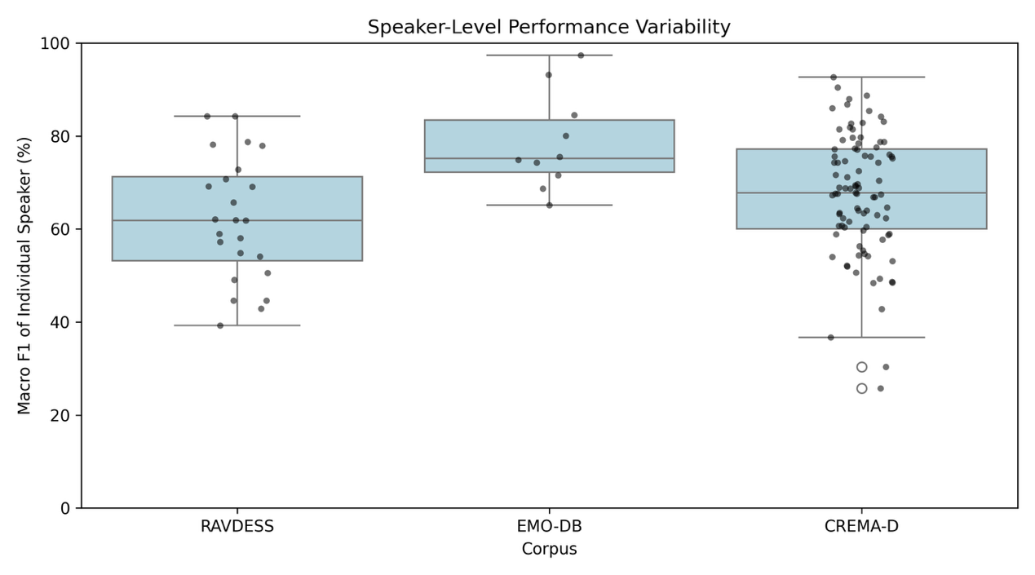[ Figure 3: Speaker-level performance variability]
The standard deviation measures how much the individual speakers’ Macro F1 scores varied around the corpus mean. The range represents the difference between the highest-performing and lowest-performing test speakers.
CREMA-D had the largest range, with individual-speaker Macro F1 scores spanning from 25.77% to 92.65%. RAVDESS and CREMA-D also had speaker-level standard deviations of approximately 13 percentage points.
This demonstrates that the same model may work well for some unseen speakers but poorly for others, even when all speakers belong to the same corpus.

7.6 Interpretation
The three-corpus extension demonstrates that SER performance depends not only on the classifier and acoustic features but also on the corpus and the individual test speaker.
The same feature-extraction and SVM pipeline produced substantially different Macro F1 scores across RAVDESS, EMO-DB, and CREMA-D. Furthermore, considerable performance variation remained among unseen speakers within each corpus.
These results provide important context for the main intensity-mismatch study. The intensity findings were obtained from RAVDESS and may therefore partly depend on the characteristics of that corpus.
The present extension does not determine whether the same intensity-mismatch pattern occurs in other corpora, but it shows why results from a single corpus should not automatically be treated as universally generalizable.
A future study could apply compatible intensity labels across additional corpora or conduct carefully controlled cross-corpus evaluation. However, corpus mismatch would need to be separated from differences in language, recording conditions, acting style, and speaker population.

8. Limitations and Future Work

8.1 Discrete Intensity Labels
The main experiment represented emotional intensity using only two levels: Normal and Strong. This design enabled a controlled comparison, but real emotional expression varies along a continuous spectrum rather than switching between two fixed states.
Future work could introduce several perceived-intensity levels or ask independent listeners to rate each recording on an intensity scale. Pairwise comparisons could also be used to determine which of two recordings sounds more emotionally intense.

8.2 Acted Rather Than Spontaneous Emotion
RAVDESS and the other corpora primarily contain emotions performed by actors under controlled instructions. Acted speech provides clear labels and standardized recordings, but it may exaggerate acoustic differences between emotions.
Naturally expressed emotions in daily human–computer interaction may be subtler and less clearly separated. A future study could collect spontaneous or semi-natural speech with appropriate consent and ethical safeguards.

8.3 Reliance on One Main Corpus for the Intensity Study
The intensity-mismatch experiment was conducted using RAVDESS because it provides explicit Normal and Strong intensity labels.
Although the three-corpus extension showed that performance varies across corpora, it did not test intensity mismatch in EMO-DB or CREMA-D. Therefore, the exact magnitude and direction of the mismatch effects should not automatically be generalized to every language or dataset.

8.4 Small External Volunteer Pilot
The external pilot contained only 62 recordings from three volunteers. It showed that the pipeline could be applied to previously unseen, home-recorded speakers, but the sample was too small for firm conclusions.
A larger follow-up should recruit more speakers, balance the number of recordings across conditions, standardize microphone distance and recording instructions, and collect independent listener ratings to verify the intended emotion and intensity.

8.5 Use of One Main Classifier
The main conclusions were obtained using an SVM with an RBF kernel. Testing only one main classifier makes it uncertain whether the same mismatch patterns would appear with other machine-learning methods.
Future work could compare the SVM results with Logistic Regression, Random Forest, or other classifiers under identical speaker-independent splits. Similar results across several models would provide stronger evidence that intensity mismatch is a general data-distribution problem.

8.6 Temporally Summarized Features
The pipeline summarized every recording using the means and standard deviations of handcrafted acoustic features. This produced an interpretable representation, but it compressed changes occurring over time.
Two recordings with different emotional contours could therefore receive similar summary values. Future work could examine frame-level feature trajectories or compare the current approach with sequence-based models.

8.7 Corpus and Recording Confounds
The three corpora differ simultaneously in language, number of speakers, acting style, recording equipment, class distribution, and other factors.
Consequently, the three-corpus extension demonstrates that performance varies across corpora, but it cannot determine which individual difference caused that variation.
Overall, these limitations define the scope of the study rather than invalidate its findings. Within this scope, the results consistently show that emotional-intensity mismatch can substantially alter recognition performance and produce directional, emotion-specific errors.

9. Project Contributions and Practical Significance

9.1 Quantifying Intensity Mismatch
The project does not only show that intensity mismatch reduces SER performance. It quantifies the size of the reduction, compares both mismatch directions, and identifies which emotions are affected most strongly.
Matched-intensity conditions achieved approximately 78–81% Macro F1, whereas mismatched conditions fell to approximately 39–46%.

9.2 Providing an Interpretable Acoustic Explanation
The project connected classification performance with measurable changes in the speech signal. Strong expressions generally produced higher energy and pitch than Normal expressions, while MFCC values also changed across intensity conditions.
These feature shifts provide a plausible explanation for the observed classification errors. The system was therefore examined as an interpretable signal-processing pipeline rather than only through a final accuracy score.

9.3 Demonstrating a Practical Robustness Strategy
Mixed-intensity training achieved approximately 73–74% Macro F1 when tested on either Normal or Strong speech.
Although this was slightly below the best matched-condition performance, it was substantially better than training on only one intensity and testing on the other.
This suggests that an SER system intended for real users should be trained on speech covering several expression intensities.

9.4 Examining Generalization to Unseen Speakers
Speaker-independent evaluation ensured that recordings from the same actor were not divided between training and testing.
The three-corpus extension further showed that performance differed not only between corpora but also among individual unseen speakers within the same corpus. This highlights how an average score can conceal poor performance for particular users.

9.5 Integrating Signal Processing and Machine Learning
From an ECE perspective, the project connects several stages of an end-to-end system:
- digital speech recordings represent physical acoustic signals;
- signal-processing methods convert recordings into measurable features;
- scaling and missing-value handling prepare the features;
- an SVM learns nonlinear decision boundaries;
- speaker-independent evaluation measures performance on unseen users;
- confusion matrices and acoustic analysis diagnose system failures.
The project therefore demonstrates how physical signals can be sampled, processed, mathematically represented, and used in an intelligent classification system.

9.6 Relevance to Human–Computer Interaction
Current voice interfaces can convert speech into text, but recognizing spoken words does not necessarily reveal how the user is expressing them.
An emotion-aware system could potentially adapt its response when a user sounds frustrated, upset, or highly excited. However, the system developed in this project should not be interpreted as reading a person’s true internal emotional state.
The practical contribution is identifying emotional intensity as a source of distribution mismatch and showing that including varied intensities during training can make speech-based emotion interfaces more robust.

10. Project Ownership and Use of AI Assistance
This was an AI-assisted research project. I began the project as a Python beginner, so I did not independently write most of the implementation from scratch.
AI tools generated and revised much of the Python code according to the experimental requirements developed during the project. They also assisted with troubleshooting the Colab workflow, explaining technical concepts, proposing possible analyses, and improving the organization and English expression of this report.
My personal contribution began with identifying the broader problem. I was interested in why a computer could recognize spoken words but could not easily respond to the emotion expressed through a user’s voice.
After observing that my mother’s more strongly expressed recordings were classified more successfully than my own recordings, I focused the project on emotional expression intensity. With assistance from AI explanations, literature searches, and academic feedback, I refined this observation into comparisons among intensity-matched, intensity-mismatched, and mixed-intensity conditions.
I was responsible for carrying out and documenting the experimental process. This included:
- selecting and refining the final project direction;
- obtaining and organizing the speech corpora;
- running the notebooks and monitoring their outputs;
- checking dataset sizes, labels, speaker identifiers, missing values, and pitch-extraction failures;
- comparing feature groups and experimental conditions;
- recruiting volunteers and organizing the external pilot;
- recording unexpected results and deciding which follow-up analyses were needed;
- studying the purpose of the main methods and metrics; and
- interpreting the results with AI-assisted explanations.
The three-corpus extension was motivated by feedback from Professor Tomoki Toda, who suggested evaluating standard SER corpora separately before attempting to interpret corpus mismatch.
The numerical results in this report were produced by executing the analysis on the stated datasets; they were not generated as hypothetical results by AI. The notebooks included checks of file counts, class distributions, speaker counts, missing values, failed feature extraction, and saved outputs.
Because the implementation was AI-assisted, this project should not be presented as evidence that I independently programmed an entire machine-learning system. Instead, it represents my development in using computational tools to investigate a question, refining an experiment after unexpected observations, evaluating evidence critically, and communicating findings and limitations transparently.

11. Conclusion
This project investigated how emotional expression intensity affects speaker-independent speech emotion recognition. Using RAVDESS recordings, 31 acoustic features, and an RBF-SVM classifier, the study compared intensity-matched, intensity-mismatched, and mixed-intensity training conditions for Happy, Sad, and Angry speech.
The Fusion feature set achieved Macro F1 scores of 77.77% and 80.98% under the two matched conditions. Performance fell to 45.51% when training on Normal speech and testing on Strong speech, and to 39.12% in the reverse direction.
The errors were directional and emotion-specific. Strong Happy speech was frequently misclassified as Angry, while Normal Angry speech was often misclassified as Happy or Sad after training only on Strong expressions.
Acoustic analysis showed that Strong expressions generally differed from Normal expressions in pitch, energy, duration, and spectral characteristics. These shifts provide a plausible explanation for why a classifier trained on only one intensity level may fail when the test distribution changes.
Mixed-intensity training reduced this problem, producing Macro F1 scores of 72.60% and 73.87% across the two test intensities. This indicates that including varied expression intensities during training can improve robustness, even if it does not always reach the performance of a perfectly matched condition.
The external volunteer pilot provided limited exploratory support for the acoustic differences between Weak and Strong expressions, although its small sample size prevents firm conclusions.
Separate evaluations of RAVDESS, EMO-DB, and CREMA-D also demonstrated that SER performance varies across corpora and among individual unseen speakers. These findings reinforce the need to evaluate models beyond a single average score or a single controlled dataset.
Overall, the project shows that an SER system may learn relationships between emotional labels and the intensity patterns present in its training data rather than representations that remain stable across all speaking styles.
For real-world human–computer interaction, training data should therefore include multiple expression intensities and diverse speakers. The system developed here does not determine a person’s true internal emotion; instead, it provides a small-scale and interpretable investigation of how vocal expression intensity influences machine classification.

